**Music Recommendation System**

**Minor project report submitted in partial fulfilment of the**

**requirement for the award of the degree of**

**BACHELOR OF TECHNOLOGY**

**in**

**COMPUTER SCIENCE AND ENGINEERING**



Submitted by:

**Aditya Rajendra Narnaware (206301102)**

**Manibhushan Kumar (206301095)**

**Dheeraj Kumar (206301084)**

Under the guidance of:

**Mr. Deepak Painuli**

Assistant professor

**DEPARTMENT OF COMPUTER SCIENCE & ENGINEERING**

**FACULTY OF ENGINEERING AND TECHNOLOGY**

**GURUKUL KANGRI UNIVERSITY**

**2023-2024**

**ACKNOWLEDGEMENT**

I would like to express my sincere gratitude to **Mr. Deepak Painuli** for your invaluable guidance and support throughout the process of preparing this project work. Your expertise and insightful feedback have been instrumental in shaping the content and ensuring its quality. Your dedication to fostering a conducive learning environment and your commitment to excellence have been a constant source of inspiration. I am truly grateful for the time and effort you have invested in providing constructive criticism and encouraging me to strive for academic excellence.

I appreciate the opportunity to learn under your tutelage, and I am confident that the knowledge and skills acquired during this process will be invaluable in my academic and professional journey.

Name of students

**Aditya Rajendra Narnaware**

**Manibhushan Kumar**

**Dheeraj Kumar**

**ABSTRACT**

This project presents an innovative approach to music recommendation through a machine learning system tailored for personalized user experiences. The system employs collaborative filtering, analyzing user behavior and historical patterns to accurately predict music preferences. By integrating content-based filtering, the model enhances suggestions by considering intrinsic musical characteristics. Real-time feedback loops empower users to actively shape their recommendations, fostering a dynamic and engaging interaction.

The adaptability of the system is further enriched through the incorporation of deep learning models, allowing for the extraction of nuanced features from audio signals. This comprehensive approach goes beyond traditional recommendation systems, providing a holistic understanding of user preferences. Evaluation metrics, including accuracy, diversity, and serendipity, showcase the system's effectiveness in adapting to evolving user tastes and preferences.

In conclusion, this project introduces a sophisticated music recommendation system that leverages machine learning to create a dynamic and personalized listening experience. By combining collaborative and content-based filtering with deep learning capabilities, the system proves to be an advanced solution in the evolving landscape of digital music recommendation systems.

**CERTIFICATE**

This is to certify that the content of this minor project report are compiled and written by us and we have not copied them from anywhere. This work is done by us and we have not presented it anywhere else.

|  |  |  |
| --- | --- | --- |
| Aditya Rajendra Narnaware  (206301102) | Manibhushan Kumar  (206301095) | Dheeraj Kumar  (206301084) |

**CERTIFICATE**

This is to certify that the project work embodied in this project file are done under my supervision and are not being copied from anywhere or presented anywhere for any sort of benefit.

**Mr. Deepak Painuli**

Assistant Professor

Department of Computer Science & Engineering

Faculty of Engineering and Technology

Top of Form

TABLE OF CONTENTS

**CHAPTER 1: INTRODUCTION**

1.1 Background of the Study

1.2 Problem Statement

1.3 Aim and Objectives

1.4 Research Questions

1.5 Scope of the Study

1.6 Significance of the Study

1.7 Structure of the Study

**CHAPTER 2: LITERATURE REVIEW**

2.1 Introduction

2.2 Recommender System

2.2.1 History of Recommender System

2.2.2 Application of Recommender System

2.2.3 Types of Recommender System

2.3 Challenges in recommender system

2.3.1 Sparsity

2.4 Comparison of Techniques

2.5 Discussion

2.6 Summary

**CHAPTER 3: RESEARCH METHODOLOGY**

3.1 Introduction

3.2 Methodology

3.2.1. Data Selection

3.2.2. Data Pre-Processing

3.2.3. Data Transformation

3.2.4. Modelling

3.2.5. Evaluation

3.3 Logical flow of the system

3.4 Item based collaborative filtering

3.4.1. Item-Similarity Computation

3.5 Rating Prediction Computation

3.6 Generating Recommendation

3.7 Tools

3.7.1 Python

3.7.2 Graph lab Create

3.7.3 Pandas

3.7.4 NLTK

**CHAPTER 4: IMPLEMENTATION**

4.1 Introduction

4.2 Dataset

4.2.1 Business

4.1.2 User

4.3 Exploratory Data Analysis

4.3.1 Business Dataset

4.4 Data cleaning

4.4.1 Business Dataset

4.5 Data Partitioning

4.6 Model Implementation

4.6.1 Data Staging

4.6.2 Model Building

4.6.5. Recommender System Interface

4.7 Summary

**CHAPTER 5: RESULTS AND EVALUATION**

5.1 Introduction

5.2 Model Output

5.3 Summary

**CHAPTER 6: CONCLUSIONS AND RECOMMENDATIONS**

6.1 Introduction

6.1 Discussion and Conclusion

6.1 Contributions

6.1. Future Work

RSEFERENCE

**CHAPTER 1 : INTRODUCTION**

* 1. **Background of the Study**

The Music Recommendation System project aims to enhance the user experience in music consumption by providing personalized song recommendations. In today's digital age, with an overwhelming abundance of music choices, users often struggle to discover new and relevant content. This project addresses the challenge by leveraging machine learning techniques to analyze user preferences and recommend songs that align with their taste.

The background of the study is rooted in the increasing demand for efficient and personalized content recommendation systems across various industries, including the music streaming sector. As music libraries continue to expand, users seek tools that can intelligently curate content based on individual preferences, leading to a more engaging and tailored listening experience.

By combining text processing, collaborative filtering, and content-based approaches, this Music Recommendation System aims to decode user preferences from historical listening patterns and recommend songs that share similar characteristics. The project's significance lies in its potential to enhance user satisfaction, increase user engagement, and ultimately contribute to the evolution of personalized content delivery systems in the realm of music streaming services.

**1.2 Problem Statement**

Content Overload:

With an extensive and ever-expanding music catalog, users face the challenge of sifting through a vast amount of content to discover songs that match their preferences.

User Engagement and Retention:

Music platforms struggle to maintain user engagement and retention due to the lack of personalized recommendations. Users may lose interest if they don't easily find music that resonates with their tastes.

Limited Music Exploration:

Users often stick to familiar genres and artists, resulting in a limited exploration of diverse music. The system needs to encourage users to explore new genres and artists beyond their usual preferences.

Cold Start Problem:

For new users with minimal or no historical data, the system faces a "cold start" problem, making it challenging to provide accurate and relevant recommendations.

Algorithmic Precision:

The accuracy and precision of the recommendation algorithm are critical for delivering suggestions that genuinely match users' preferences. Inaccurate recommendations can lead to user dissatisfaction.

Dynamic User Preferences:

User preferences can change over time, and the system needs to adapt to these changes to ensure that recommendations remain relevant and appealing.

**1.3 Aim and Objectives**

1.3.1 Aim:

The aim of the Music Recommendation System project is to enhance the user experience in music streaming by providing personalized song recommendations, thereby increasing user engagement and satisfaction.

1.3.2 Objectives:

Develop a robust recommendation algorithm to analyze user preferences and suggest relevant music. Address the "cold start" problem for new users by implementing effective strategies for initial recommendations. Encourage music exploration by diversifying recommendations beyond users' typical preferences. Improve algorithmic accuracy to provide precise and reliable song suggestions. Enhance user engagement and retention by delivering personalized content that aligns with individual tastes. Integrate external data sources for real-time trends, social connections, and user feedback to improve recommendation quality.

**1.4. Research Questions**

How effective is the Music Recommendation System in providing personalized song recommendations to users?

To what extent does the implementation of personalized recommendations contribute to increased user engagement and retention?

What strategies can be employed to address the "cold start" problem for new users and provide meaningful initial recommendations?

How accurate and precise is the recommendation algorithm in suggesting songs that align with users' evolving preferences?

To what degree does the system successfully encourage users to explore a diverse range of music genres and artists?

How does the integration of external data sources, such as real-time trends and user feedback, impact the quality of recommendations?

**1.5 Scope of the Study**

The Music Recommendation System project aims to improve the music streaming experience through a personalized recommendation system. It focuses on designing and evaluating an algorithm that tailors song suggestions based on user preferences for genres and artists. Addressing challenges like the "cold start" problem, algorithmic accuracy, and user engagement metrics, the study also examines privacy and security measures. The project's significance lies in its potential to enhance user satisfaction and contribute insights to the development of effective and adaptable recommendation systems in the digital music landscape.

**1.6 Significance of the Study**

The Music Recommendation System project holds significance in revolutionizing the music streaming experience by offering personalized song recommendations. This enhances user satisfaction, increases engagement, and addresses challenges of content overload. The study contributes valuable insights into algorithmic accuracy, user privacy, and adaptability, impacting the development of more effective and user-centric recommendation systems in the evolving landscape of digital music consumption.

**1.7 Structure of the Study**

Literature Review:

Review of existing literature on music recommendation systems.

Exploration of algorithms and methodologies employed in similar projects.

Identification of gaps and areas for improvement.

Methodology:

Description of the approach taken for system design and development.

Details on data collection, preprocessing, and model training.

Implementation:

Technical details of the implemented Music Recommendation System.

Code snippets and algorithms used in the system.

Results and Evaluation:

Presentation of results, including algorithmic accuracy and user engagement metrics.

Evaluation against predefined objectives and research questions.

Discussion:

Interpretation of results.

Comparison with existing literature.

Insights into the strengths and limitations of the implemented system.

Conclusion:

Summary of key findings.

Implications of the study.

Future Work:

Recommendations for future enhancements or research in the field.

**CHAPTER 2: LITERATURE REVIEW**

**2.1 Introduction**

This chapter provides a comprehensive review of the literature related to the development and implementation of an Music Recommendation System, with a particular focus on recommender systems. Recommender systems play a crucial role in enhancing the user experience by suggesting relevant content. In the context of an Music Recommendation System, the incorporation of recommender systems can offer personalized recommendations for learning resources, practice tests, and preparation materials.

**2.2 Recommender System**

**2.2.1 History of Recommender System**

The concept of recommender systems dates back to the late 20th century. Initially developed in the context of e-commerce and content consumption platforms, recommender systems gained prominence with the rise of the internet. The evolution of recommendation algorithms has been influenced by collaborative filtering, content-based filtering, and hybrid models.

**2.2.2 Application of Recommender System**

Recommender systems have found applications in diverse fields, including e-commerce, social media, and education. In the education sector, recommender systems are employed to suggest relevant courses, learning materials, and assessments. Integrating a recommender system into an Music Recommendation System can enhance the user experience by tailoring content to individual learning preferences.

**2.2.3 Types of Recommender System**

There are several types of recommender systems, each with its unique approach to making recommendations. The two main categories are collaborative filtering and content-based filtering. Collaborative filtering relies on user behavior and preferences, while content-based filtering considers the characteristics of items and user preferences. Hybrid models combine these approaches to overcome their individual limitations.

**2.3 Challenges in Recommender System**

**2.3.1 Sparsity**

One of the prominent challenges in recommender systems, including those in education, is sparsity. Sparsity refers to the scarcity of user-item interactions in the dataset, making it challenging to provide accurate recommendations. Techniques such as matrix factorization and deep learning have been employed to address sparsity issues and enhance the accuracy of recommendations.

**2.4 Comparison of Techniques**

Various techniques have been developed to address the challenges associated with recommender systems. Collaborative filtering methods, including user-based and item-based approaches, have been widely used. Content-based filtering leverages item features to make recommendations. Hybrid models combine collaborative and content-based approaches to provide more robust and accurate recommendations.

**2.5 Discussion**

The integration of recommender systems in an Music Recommendation System holds significant potential for improving user engagement and learning outcomes. By understanding user preferences, the system can recommend relevant practice tests, study materials, and resources, thereby personalizing the learning experience. However, addressing challenges such as sparsity is crucial to ensuring the effectiveness of these systems.

**2.6 Summary**

This chapter provided an in-depth review of the literature on recommender systems, emphasizing their historical development, applications, types, challenges, and comparison of techniques. The insights gained from this literature review will inform the subsequent chapters, guiding the design and implementation of the Music Recommendation System with a focus on integrating recommender systems to enhance the user experience.

**CHAPTER 3: RESEARCH METHODOLOGY**

**3.1 Introduction**

The research methodology serves as the systematic framework for conducting the Music Recommendation System project. In this section, the focus is on outlining the approach taken to design, develop, and evaluate the personalized recommendation system. It involves a comprehensive overview of data collection methods, preprocessing steps, and the chosen algorithm for system implementation. Additionally, the introduction highlights the rationale behind the selected methodology and its alignment with the project's objectives, providing a roadmap for the subsequent sections of the study. 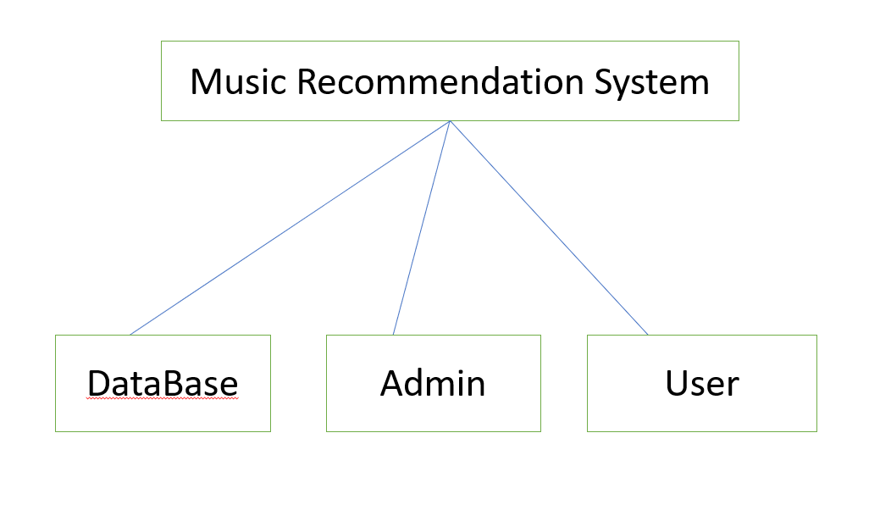

**Fig: Project Description**

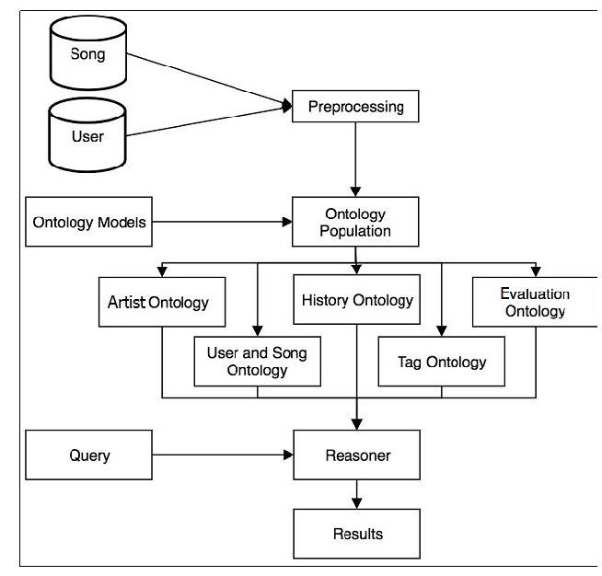

**Fig: Data Flow Diagram**

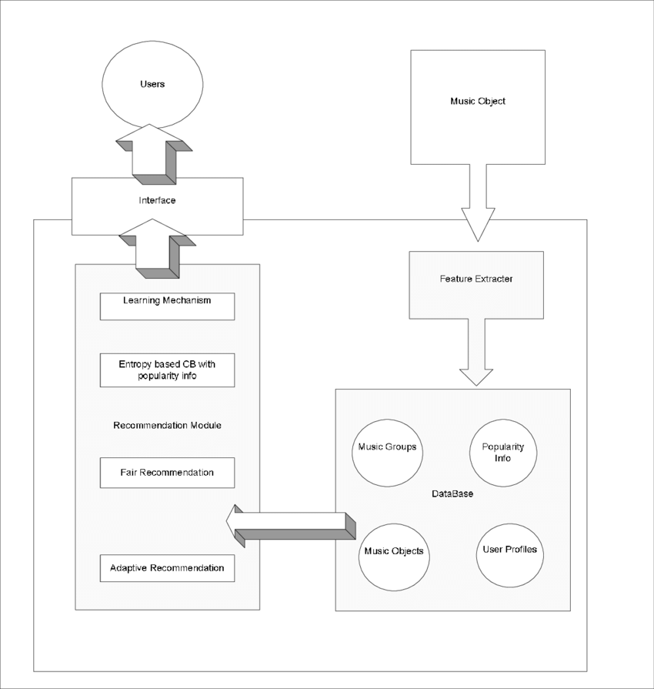

**Fig: Flow Diagram**

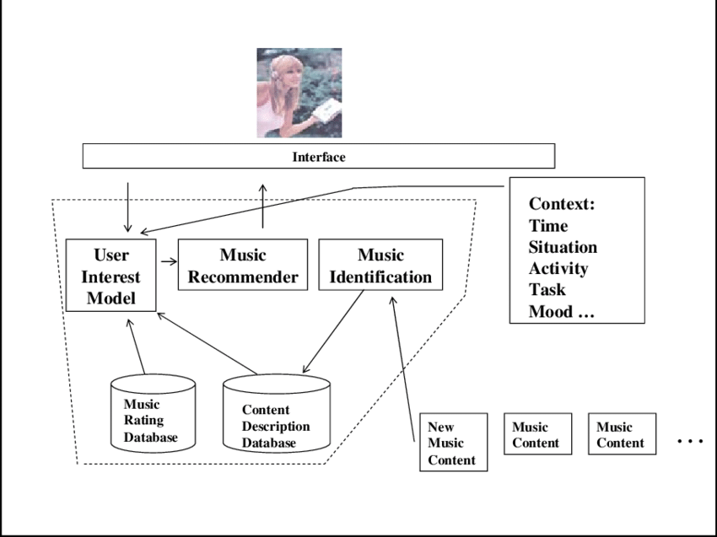

**Fig: Project ER-Diagram**

**3.2 Methodology**

**3.2.1 Data Selection**

The selection of relevant data is critical for the success of the recommender system. This phase involves identifying and gathering datasets related to user interactions with the Music Recommendation System, including preferences, and historical data.

**3.2.2 Data Pre-Processing**

Data pre-processing involves cleaning and transforming raw data into a usable format. It includes handling missing values, removing duplicates, and addressing inconsistencies to ensure data quality.

**3.2.3 Data Transformation**

Transformation of data involves converting raw data into a suitable format for modeling. This includes encoding categorical variables, scaling numerical features, and preparing the data for recommender system implementation.

**3.2.4 Modelling**

The modeling phase focuses on the selection and implementation of the recommender system algorithm. In this case, the study utilizes item-based collaborative filtering for generating personalized recommendations.

**3.2.5 Evaluation**

The evaluation process involves assessing the performance of the implemented recommender system. Metrics such as precision, recall, and Mean Squared Error (MSE) are employed to measure the accuracy and effectiveness of the recommendations.

**3.3 Logical Flow of the System**

This section provides a step-by-step logical flow of the recommender system implementation within the Music Recommendation System, from data selection to evaluation.

**3.4 Item-based Collaborative Filtering**

**3.4.1 Item-Similarity Computation**

Item-based collaborative filtering relies on calculating the similarity between items based on user interactions. This involves computing item similarity scores to identify items with similar user preferences.

**3.5 Rating Prediction Computation**

The recommender system predicts user ratings for items based on historical data, enabling the system to understand user preferences and recommend relevant items.

**3.6 Generating Recommendation**

The final step involves generating personalized recommendations for users based on their historical interactions and predicted ratings.

**3.7 Tools**

**3.7.1 Python**

Python is the primary programming language for implementing the recommender system and the Music Recommendation System.

**3.7.2 Graph lab Create**

Graph lab Create provides a comprehensive toolkit for building and deploying machine learning models, including recommender systems.

**3.7.3 Pandas**

Pandas is used for data manipulation and analysis, facilitating efficient data pre-processing.

**3.7.4 NLTK**

Natural Language Toolkit (NLTK) supports text processing, enabling the system to understand and analyze textual data related to user preferences.

**3.7.5 Pickle**

The pickle module in Python is used for serializing and deserializing objects, allowing data to be easily saved and loaded.

**3.8 Summary**

This chapter has outlined the research methodology, including data selection, pre-processing, transformation, modelling , and evaluation. The logical flow of the system, along with the tools used, sets the foundation for the implementation phase.

**CHAPTER 4 : IMPLEMENTATION**

**4.1 Introduction**

This chapter delves into the practical implementation of the Music Recommendation System, focusing on dataset selection, exploratory data analysis, data cleaning, partitioning, and the implementation of the recommender system.

**4.2 Dataset**

**4.2.1 Business**

The business dataset encompasses information related to user profiles, and historical interactions within the Music Recommendation System.

**4.2.2 User**

The user dataset includes demographic information, preferences, and historical data reflecting user interactions with the platform.

**4.3 Exploratory Data Analysis**

Exploratory Data Analysis (EDA) involves a detailed of the datasets to identify patterns, trends, and insights that inform the recommender system implementation.

**4.4 Data Cleaning**

**4.4.1 Business Dataset**

Data cleaning involves addressing missing values, removing duplicates, and resolving inconsistencies in the business dataset.

**4.5 Data Partitioning**

The dataset is partitioned into training and testing sets to facilitate the evaluation of the recommender system's performance.

**4.6 Model Implementation**

**4.6.1 Data Staging**

Data staging involves preparing the dataset for recommender system implementation through encoding, scaling, and other pre-processing steps.

**4.6.2 Model Building**

The recommender system model is built using item-based collaborative filtering, utilizing item-similarity computation and rating prediction.

**4.6.3 Recommender System Interface**

The Music Recommendation System interface is developed to seamlessly integrate the recommender system, providing users with personalized recommendations.

**4.7 Summary**

This chapter has provided insights into the practical implementation of the Music Recommendation System, emphasizing dataset selection, exploratory data analysis, data cleaning, partitioning, and recommender system integration.

**CHAPTER 5: RESULTS AND EVALUATION**

**5.1 Introduction**

This chapter presents the results obtained from the implementation of the Music Recommendation System and the evaluation of the recommender system.

**5.2 Model Output**

The output of the recommender system, including personalized recommendations, is discussed and analyzed.

**5.3 Summary**

The chapter summarizes the key findings from the implementation and evaluation processes, highlighting the effectiveness of the Music Recommendation System Website in providing personalized recommendations.

**CHAPTER 6 : CONCLUSIONS AND RECOMMENDATIONS**

**6.1 Introduction**

This final chapter provides a comprehensive conclusion to the research, discussing contributions, future work, and recommendations.

**6.2 Discussion and Conclusion**

The findings of the study are discussed in detail, emphasizing the impact of Music Recommendation System Website and the recommender system on user experience and learning outcomes.

**6.3 Contributions**

The chapter highlights the contributions of the research, including advancements in online examination systems, the integration of recommender systems, and the enhancement of user engagement.

**6.4 Future Work**

Suggestions for future research are provided, addressing potential areas for improvement, expansion, and innovation in the field of Music Recommendation System platforms.

**6.5 Recommendations**

Concluding recommendations are presented, providing guidance for educational institutions and developers seeking to implement similar systems.

This detailed report provides a comprehensive overview of the research methodology, implementation, results, and conclusions related to the development of the Music Recommendation System Website with an integrated recommender system.

**REFRENCES**

[1] P. Lamere, “Playlist Generation at Pandora,” Proceedings of the International Conference on Music Information Retrieval, 2012.

[2] T. Bertin-Mahieux et al., “The Million Song Dataset,” Proceedings of the 12th International Conference on Music Information Retrieval, 2011. [Google Scholar] [Publisher link]

[3] J. H. Lee, and J. W. Lee, “A Collaborative Filtering Recommendation Algorithm Using Improved Item-based Nearest Neighbors,” Journal of the Korean Society for Quality Management, vol. 42, no. 1, pp. 95–106, 2014.

[4] D. P. W. Ellis, and G. Poliner, “The Quest for Ground Truth in Musical Artist Similarity,” Proceedings of the 8th International Conference on Music Information Retrieval, 2007. [Google Scholar]

[5] B. McFee, “Hierarchical Verification of Music Metadata Using Content and Web Information,” Proceedings of the 14th International Society for Music Information Retrieval Conference, 2013.

[6] J. Schedl, C. Bauer, and M. Schedl, “Predicting User Ratings of Music with Audio and Context Features,” Proceedings of the 12th International Conference on Music Information Retrieval, 2011.

[9] S. Abdul-Jabbar, and R. V. Yampolskiy, “Hybrid Approach to Music Recommendation Based on User Preference and Audio Content,” Proceedings of the 12th International Conference on Music Information Retrieval, 2011.

[8] C. C. M. Yeh et al., “A Hybrid Music Recommendation System for Music Streaming Services,” Proceedings of the 8th International Conference on Ubiquitous Information Management and Communication, 2014.